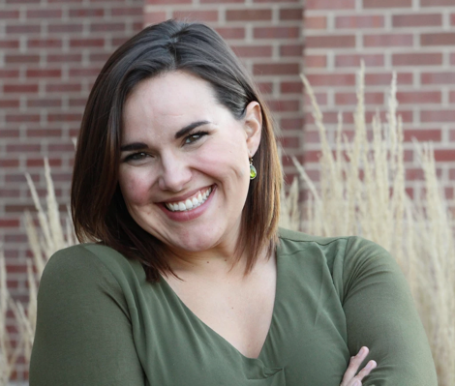
Kelci Kosin
Lyric Soprano
kelcidalayne@gmail.com
www.kelcikosin.com
810-588-8132

Roles Performed
Mom A Christmas Story Muncie Civic Theatre 2020
Miss Honey Matilda Muncie Civic Theatre 2020
Grace Annie Muncie Civic Theatre 2018 Suor Angelica Suor Angelica Ball State Opera Theatre 2018
Countess Almaviva Le Nozze Di Figaro Ball State Opera Theatre 2017
Rosalinda Die Fledermaus Ball State Opera Theatre 2016
Trang/Nurse Amelia Chicago College of Performing Arts 2013
Helene Hin und züruck Chicago College of Performing Arts 2013
Mimi La Bohème University of Evansville Opera 2012
Fiordiligi Cosí fan tutte University of Evansville Opera 2011
Nursing Sister Suor Angelica University of Evansville Opera 2010
Gretel Hansel and Gretel University of Evansville Opera 2009
Lola Gallantry University of Evansville Opera 2008

Concert/Oratorio
Soprano Soloist Tomasi’s Procession Nocturne Ball State University 2020
Soprano Soloist Songs of Love and Death* International Music by Women Festival 2020
Soprano Soloist Cartes postales de la guerre* Sursa America Organ Competition 2019
Soprano Soloist Love Me Like a Beautiful Dream* International Horn Symposium 2019
Soprano Soloist Rutter’s Requiem Masterworks Chorale 2019
Soprano Soloist Beethoven’s Ninth Symphony Ball State University 2019
Soprano Soloist Vivaldi’s Gloria Masterworks Chorale 2018
Soprano Soloist Carmina Burana Ball State University 2017
Soprano Soloist Middletown Chronicles* Masterworks Chorale 2016
Soprano Soloist Petite Messe Solennelle Chicago College of Performing Arts 2012

*premiere
Education
Ball State University Doctor of Arts July 2019
Chicago College of Performing Arts Master of Music, Voice Performance May 2013
University of Evansville Bachelor of Music, Voice Performance May 2011
Up North Vocal Institute 2012

Awards
Outstanding Graduate Student Award Ball State School of Music Honors Convocation 2019
1st place Ball State Vocal Competition 2017 Semi-finalist Harold Haugh Vocal Competition 2016
2nd place Ball State Vocal Competition 2016
1st place University of Evansville Concerto Competition 2012
1st place NATS Vocal Competition 2011
2nd place University of Evansville Gumbert’s Competition 2011
1st place Schmidt Vocal Competition 2007

Voice Teachers Vocal Coaches Masterclasses
Jon Truitt Hyery Hwang Martin Katz
David Holloway Dana Brown Rebecca Shorsch
Cara Chowning Mary Jean Allen
Daron Hagen
John Van Cura

